Enumerated Datatypes and Typedefs assignments

Mandatory
- WAP to define an enum to store designations in an organization. List of possible values are
{E2F=1, E2, E3, E4, E5}
Prompt and read a designation from the user. Then display his designation string such as
Designation | Designation String
E2F | Software Fresher
E2 | Software Engineer
E3 | Senior Software Engineer
E4 | Team Lead
E5 | Senior Team Lead
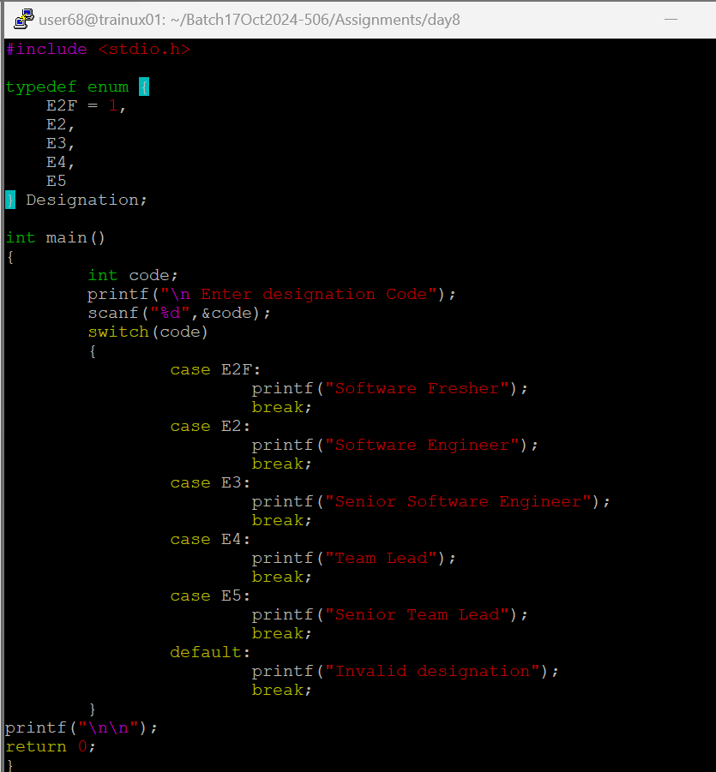
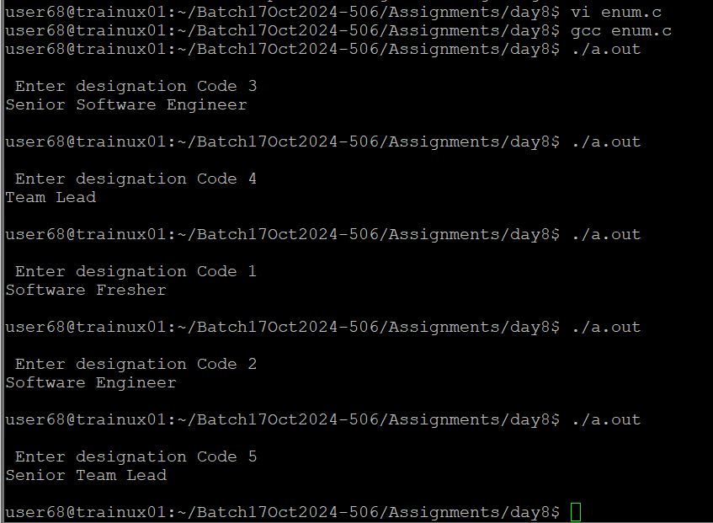

- Define a typedef structure to keep the configuration of putty server. Identify and place all the required members. Create a structure variable and initialize it with user defined values and finally display the contents.
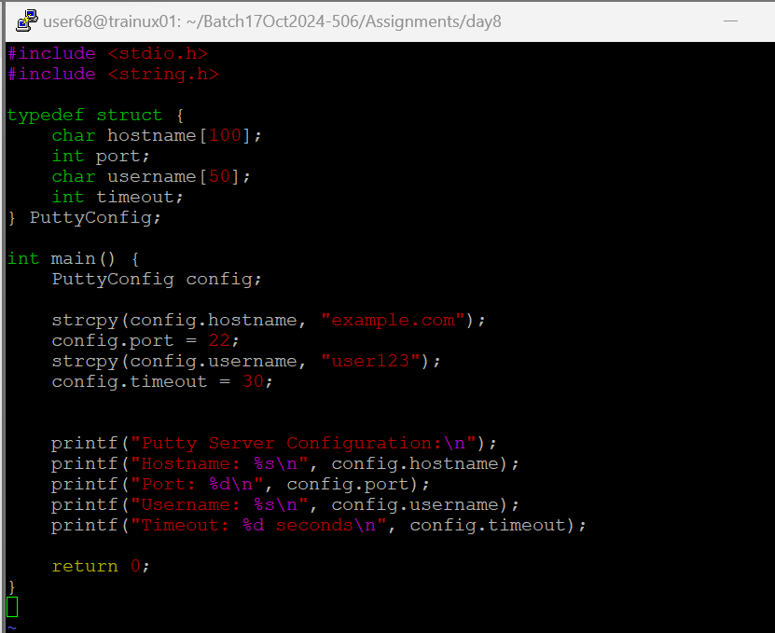

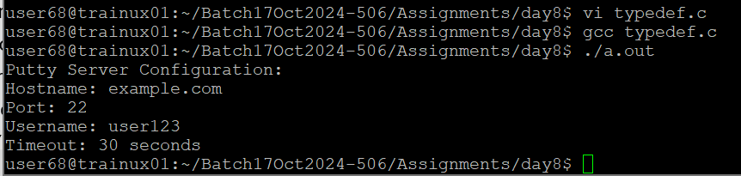
Optional:
- Store and display the details of different places.
The places are categorized as metropolitan, tourist place
Place name and the country are common.
For metropolitan, additional information are ‘population’ and ‘area’. For tourist place, it is ‘Nearest airport and “type” (Beach, Hill station,..).
Use structures and unions wherever needed.
Modularize your program and use pointers. Create make file.
Return from functions has to be defined as an enumerated data type.

